

**GROUP ASSIGNMENT**

**TECHNOLOGY PARK MALAYSIA**

**AINT002-4-2-IA**

**INTERNET APPLICATION**

**UCDF1709**

**NAME OF LECTURER: DR. SITI AZREENA BINTI MUBIN**

**HAND OUT DATE: 23RD JULY 2018**

**HAND IN DATE: 1ST OCTOBER 2018**

**WEIGHTAGE: 50%**

**INSTRUCTIONS TO CANDIDATES:**

1. **Submit your assignment at the administrative counter.**
2. **Students are advised to underpin their answer with the use of references**

**(cited using the Harvard Name System of Referencing).**

1. **Late submission will be awarded zero (0) unless Extenuating Circumstances (EC) are upheld.**
2. **Cases of plagiarism will be penalized.**
3. **The assignment should be bound in an appropriate style (comb bound or stapled).**
4. **Where the assignment should be submitted in both hardcopy and softcopy, the softcopy of the written assignment and source code (where appropriate) should be on a CD in an envelope / CD cover and attached to the hardcopy.**



**GROUP ASSIGNMENT**

**TECHNOLOGY PARK MALAYSIA**

**AINT002-4-2-IA**

**INTERNET APPLICATION**

**UCDF1709**

**NAME OF LECTURER: DR. SITI AZREENA BINTI MUBIN**

**HAND OUT DATE: 23RD JULY 2018**

**HAND IN DATE: 1ST OCTOBER 2018**

**WEIGHTAGE: 50%**

**PROJECT TITLE: APU BADMINTON CLUB**

|  |  |
| --- | --- |
| **NAME** | **TP NUMBER** |
| Lee Wai Yen | TP044610 |
| Hen Kian Jun | TP047472 |
| Teh Yi Jia | TP048096 |

**WORD COUNT: 3427 words**

**Acknowledgement**

First, we would like to thank everyone who helped us in completing our assignment within the limited time frame. We also want to thank to Dr. Siti Azreena Binti Mubin, Course Instructor of Internet Application, at Asia Pacific University of Technology & Innovation, who gave us the golden opportunity to learn new things and gave us a lot of advises when we need the help in our assignment.

Besides that, the learning websites such as W3Schools and Mozilla Development Network are very helpful for us to complete the assignment. We are very appreciated that these learning websites provides the learning platform, otherwise we may not be able to finish the requirements of assignment within the time frame.

However, we also must thank our friends who guided us throughout the whole report and project. With this opportunity, we get to know more about the knowledge of the coding world and how it works behind the screen. Such as how does the CSS file and JavaScript file manage with HTML file, and the basic terms and conditions to develop a user-friendly website.

Table of Contents

1.0 Introduction 5

2.0 Storyboarding and Modelling 6

3.0 Evaluation 27

4.0 Future Enhancements 29

5.0 Conclusions 30

6.0 Reference Lists 31

7.0 Attachments 37

# Introduction

The assignment is to design and develop a completely working website, that is used for APU Sports club. The chosen sport for the assignment is Asia Pacific University Badminton Club. The objective of the assignment is to develop a website for APU badminton club, because the previous websites of APU badminton club are lack of information and not a well-design website, plus it does not have an individual website. The working website is created for non-members and members of APU badminton club. This working website is to provide the detailed information for those students who are interested in the badminton sport. Besides that, the working website is only offered to the Asia Pacific University students. The storyboarding and modelling sections are to demonstrate the working website layout, it shows how the website goes. Each storyboarding sections will explain the working website in detailed. The modelling section is the screenshot of the website. The website architecture is included that is used to show what are the elements insides the webpage and the functional flow chart has been included to demonstrate what are the functions of the website. In addition, the evaluation section is to discuss about how the proposed system solves the existing problems and address opportunities. Other than that, the future enhancement section is to explain the major technical problems faced development and how do solve these issues. For conclusion part, it has concluded overall the report and the working website for the future suggestions.

# Storyboarding and Modelling

**Storyboarding**

The following storyboarding contains the same header and footer layout (Figure 1) for all web pages excepted the forms of register, feedback and enquiry. The header shows an image regarding to the APU badminton club with the word ‘APU BADMINTON CLUB’, whereas the footer displays the word ‘APU Badminton Club 2018’ followed by three social media connection icons which can link to the related web pages under the horizontal line, the three social media connection icons which include Facebook (The Wild Honey Pie, 2018), Instagram (The Wild Honey Pie, 2018) and Twitter (The Wild Honey Pie, 2018). Students can access up-to-date information through the social media connections that are provided by the websites. The navigation bar shows every connection of web page such as Home, About Us, Services, Calendars and Events, News and Medias, Forms, Contact Us, and Our Sponsors. By hovering the forms, the three forms will be displayed using dropdown list style. The navigation bar will stick on the top permanently when the visitors scroll down the web pages. In addition, the title of web pages shows the same format where the word keeps moving horizontally in between the box. On the other hands, the layout of the three forms (Figure 2) consists of similar format which include the header (h1) as the title of the pages, followed by the list of texts and textboxes. The user should fill up every textbox before proceeding to the next page, otherwise the border of the box will become red colours. At the end of the forms, it contains some buttons that are allowed the users to click.

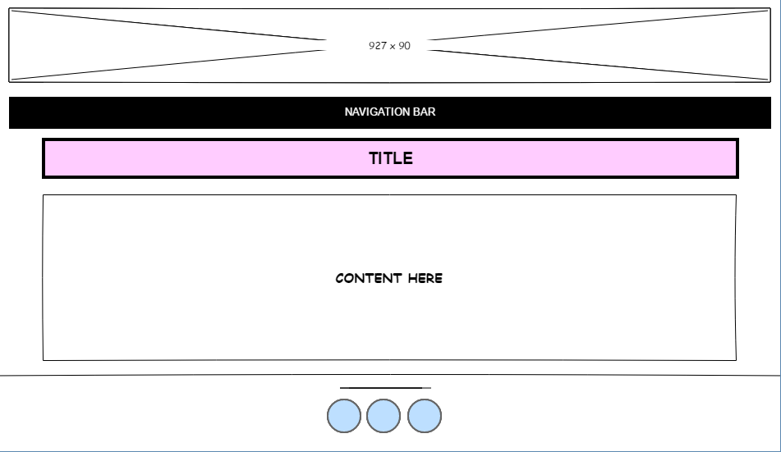

Figure 1: Layout for all webpages

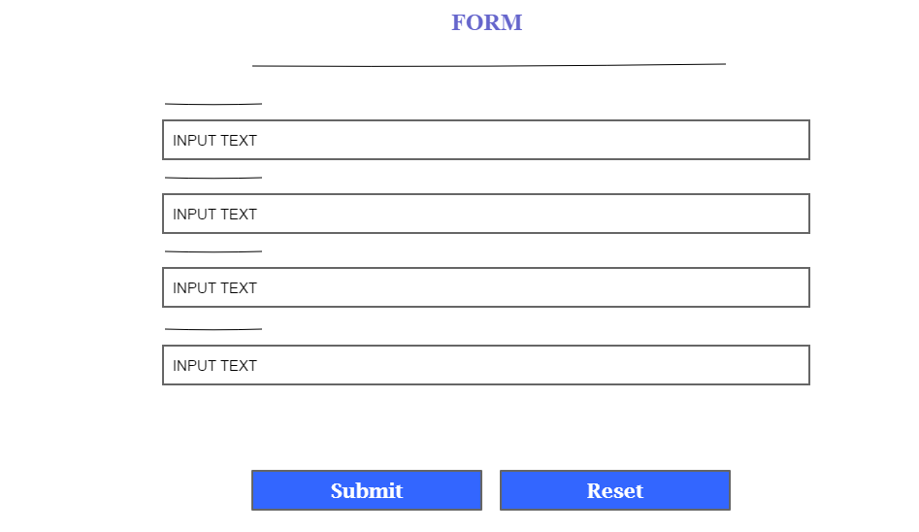

Figure 2: Layout for forms

The reset button is used to reset all the input text. By clicking the submit buttons from every form, it will prompt a message box saying that the visitors have already submitted the form using JavaScript, the three forms were applied all the same message boxes. After the message box, it will automatically link to the page (Figure 3) as below, the hyperlink listed as below is to link to related web page. Other than that, the home button is designed to link back to the home page.

Figure 3: Appreciated forms

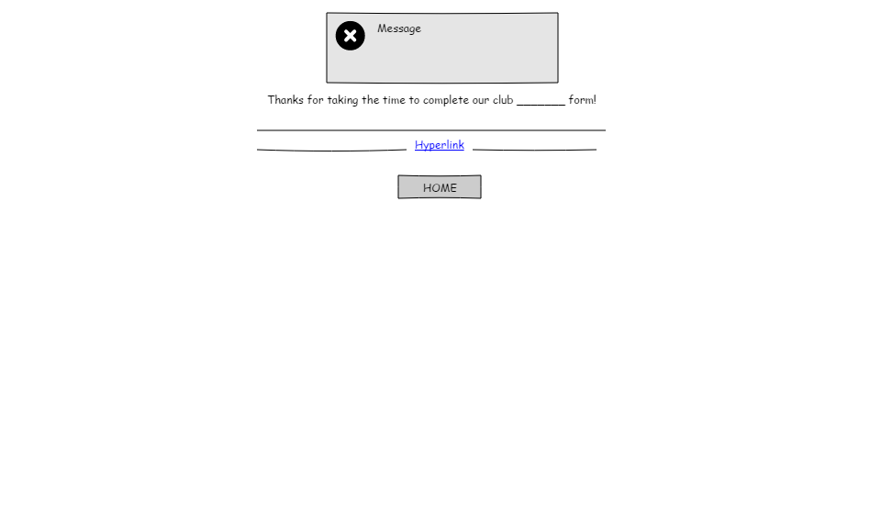

* Splash Page

The splash page (Figure 4) will prompt a message box once the user enters the web page. The action button is located at the centre of the web page which will lead the user to the main page. There is a list of navigation bar on the bottom of the web pages, that can link to the related web page.

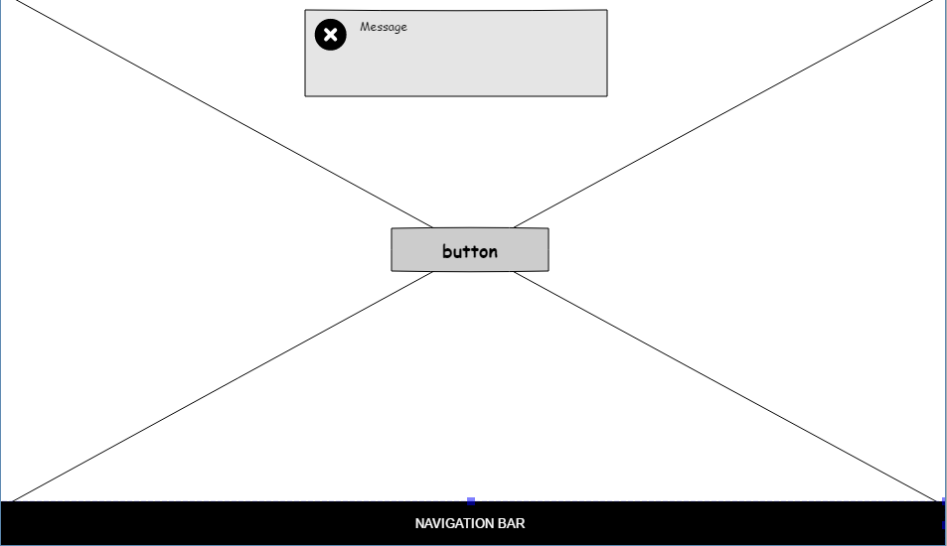

Figure 4: Splash page

* Home Page

The home page (Figure 5) shows that two single lines of greetings, and simply introduce the club description. The video (APU Beyond Media, 2017) shows the previous activities that held in APU, that is allowed any visitors to view it by clicking the play button. The slideshow shows how is the APU students training pictures (APU Badminton Club, 2018) and few friendly-match pictures are also included, it will slide automatically after every three seconds. The highlighted pictures will be uploaded to the slideshow. Besides that, it also shows the previous result (APU Badminton Club, 2018) on 2017 that APU students won the friendly-match with Sunway University. The training information is included in detailed that can be seen below the slideshow (APU Badminton, 2018). This home page is designed for displaying the breaking news that is happened in APU badminton club.

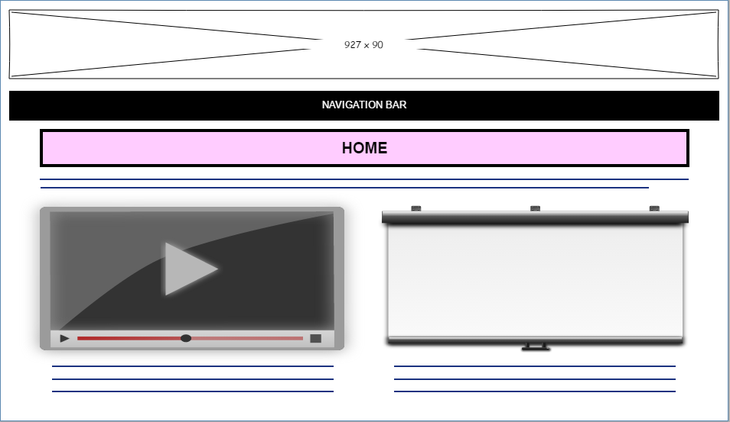

Figure 5: Home page

* About Us Page

The About Us (Figure 6) page starts with two lines of description on the objective part of the APU Badminton Club 2018. Then, it continues with a table with four rows that allow visitors to view the webpage contents easily. The first row is spilt into two columns with the contents of Vision and Mission and followed by the badminton court is used by the club and the specific objective of APU Badminton Club 2018. Last, the visitors will see four buttons which are ‘Rules and Regulations’, ‘Required Attire and Equipment’, ‘Our history’, and eventually ‘About badminton’. These four buttons will lead the visitors to new page. The four buttons are used for displaying more information about the chosen badminton club. This about us page is created for non-members and members to know about APU badminton club, students can know what the vision are, mission, objectives etc by reading this webpage.

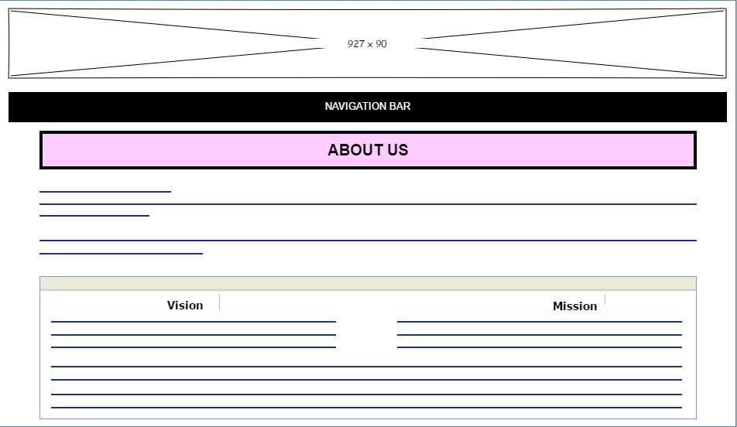

Figure 6: About Us page

* Rules and Regulation page

The rules and regulations page (Figure 7) are to show how the badminton system count the scores. It explains how the general scoring system in briefly, followed by interval and changes of ends. Besides that, also included explanation on the descriptions of singles and doubles in detailed. For more information, there is a link below the descriptions of doubles. It will lead the visitors to related web page. The webpage is created for sharing to non-members and members the rules and regulations, because sometimes the students have no any knowledge about the rules and regulations of badminton. By reading this webpage, students may know how the badminton system count the score etc.

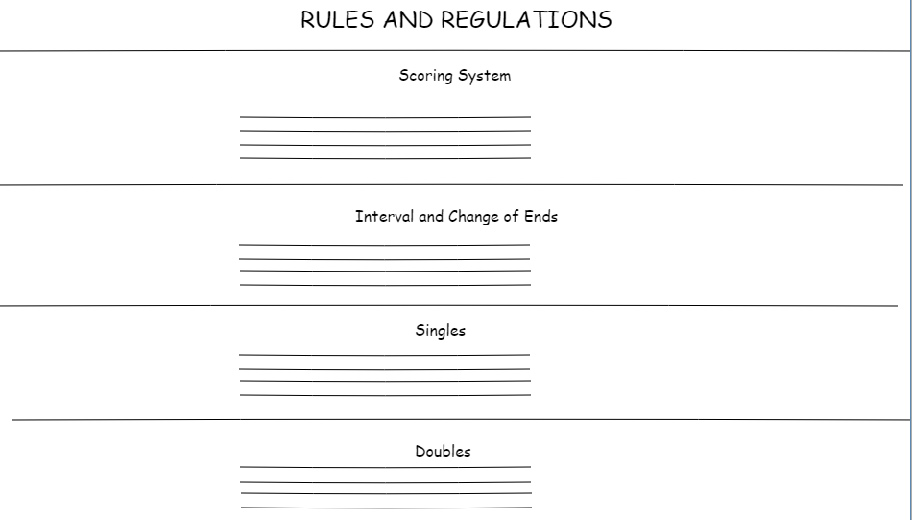

Figure 7: Rules and Regulations

* Required Attire and Equipment page

The required attire and equipment pages (Figure 8) show the requirement of the badminton club. The badminton players should follow the basic requirements before attending the training. Therefore, this webpage divided into two components which are attire and equipment. The attire component described the basic sport wear that players should commit and inserted several images (DHgate.com, 2018) (Joybuy, 2018) (Alpoega, 2017) (Health, 2018) of the attire that enable users to understand. Besides, the other component is about the equipment that players should have when playing badminton game and several images was inserted to enable users know more about the equipment such as badminton shoes (Khelmart.org, 2018) (Flipkart.com, 2018), badminton rackets (EZtrust, 2015) (Flipkart.com, 2018) etc. The webpage is designed for noticing non-members and members, the attire and equipment that are listed are the basic requirements, before attending the training should follow the requirement that is stated.

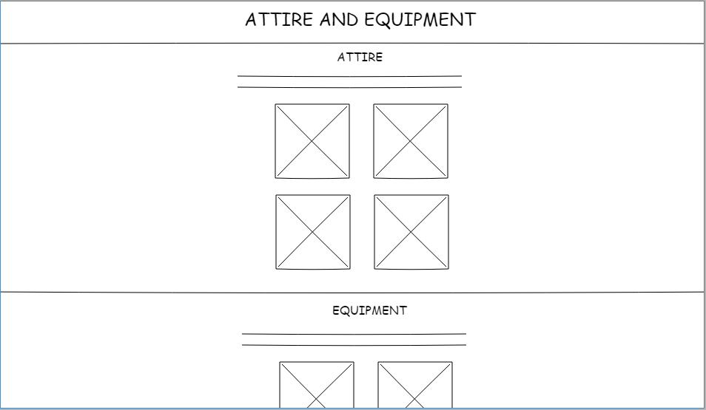

Figure 8: Attire and Equipment page

* Our history pages

Our history page (Figure 9) shows the highlighted information of the previous years, which include year 2018, year 2017, year 2016, and year 2015. The visitors can know more about the badminton club what has been done on the previous years. The webpage is to show what is the history of the badminton club, it could be attracting more students to join the badminton club. And also, what are the achievements in our history.

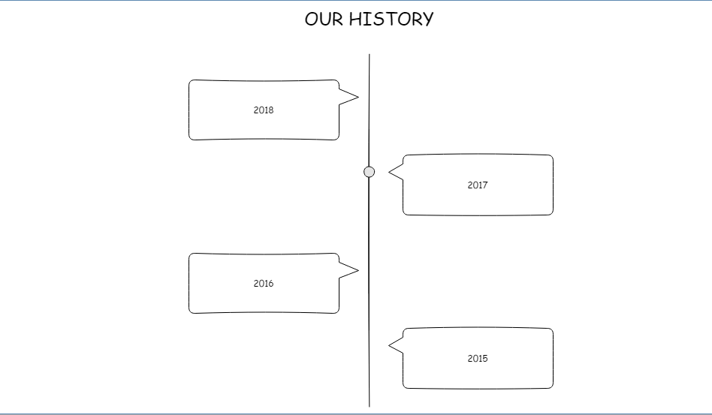

Figure 9: Our history page

* About badminton page

This page (Figure 10) shows the general knowledge of the badminton that help users to increase their knowledge about badminton. It basically describes about what is a badminton game is, where to play badminton game, how does the shuttlecock work, and basic knowledge of the badminton game involved into the Olympic game etc. However, a several gif images (Dumielauxepices.net, 2018) (OMG Fitness, 2017) (Patenik, 2018) were inserted into the webpage to make to webpage more interesting. This webpage is used to share the knowledge of the badminton, at least every student can know a little bit about badminton.

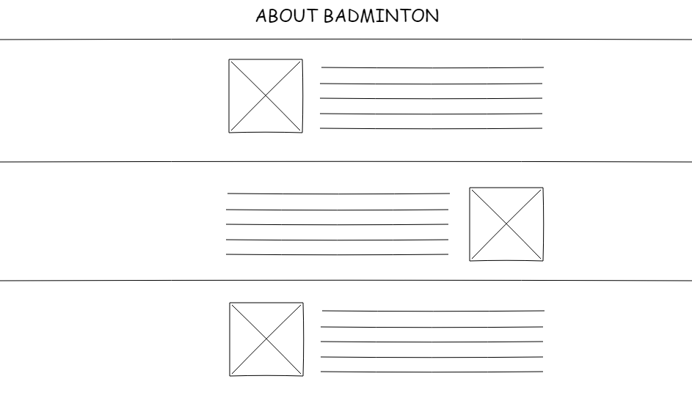

Figure 10: About badminton page

* Services Page

The services page (Figure 11) shows what are the services that are provided for APU students as well as for badminton club members. It displays few categories of coaching team such as single, double, and mixed. The pictures (Badminton Association of Malaysia - Coaching Team, 2018) show the coach's personal pictures along with the coach's full name as below. Moreover, visitors can see coach education program which is divided into three levels, each program has its own requirements. The person who is interested in, can contact through enquiry form that is under the form sector for more details. In addition, the web page provides a video, the visitor can view the video without any restrictions. The video (Sikana English, 2018) is about how to practice badminton training, the composition of 3D architecture video that is made by computer. This webpage is used for providing the services for non-members and members. Students in APU can sign a program that is provided on this webpage. The coach’s personal picture is included because it is sharing how strong is the badminton club.

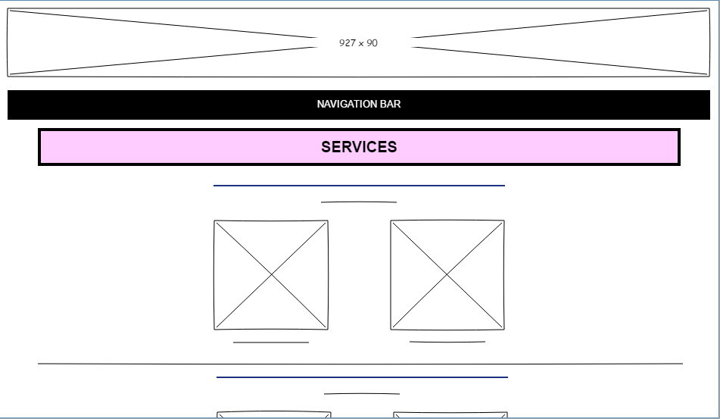

Figure 11: Services page

* Calendars and Events Page

The calendars and events page (Figure 12) show that the current events and upcoming events from APU badminton club. That allows the administrators of the web page to edit calendars that is synchronized, and it will update the information to the calendars automatically. Every update from the APU badminton club will be uploaded to the calendars (Google Calendar, 2018). The visitors will know the upcoming or current events from the APU badminton club by viewing this page.

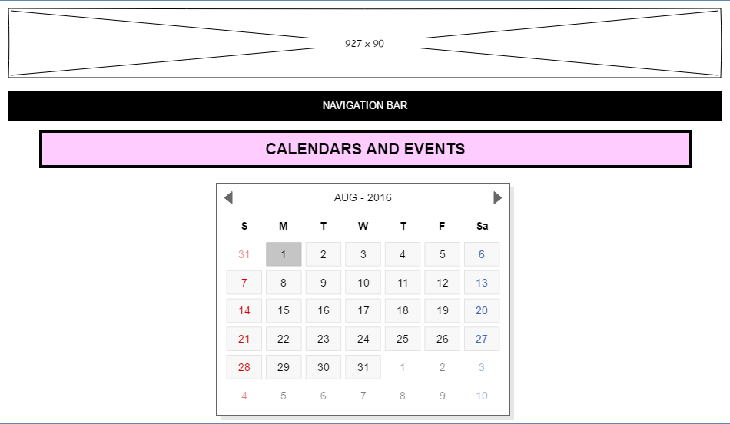

Figure 12: Calendars and Events page

* News and Medias Page

The news and medias page (Figure 13) show the latest news that was happened around the world about the university badminton events. The page only shows the highlighted news which include Asian University Championship (D'Addese, 2017), Bronze in 2018 USA open (Bryson, 2017), and three awards at Malaysia Badminton Association (E-badminton Club, 2018). The picture is provided for the evidences and followed by a few lines of descriptions as the picture below. By providing this webpage, every APU student can know more about the latest news of badminton around the world, because it will update frequently when a big event is finished.

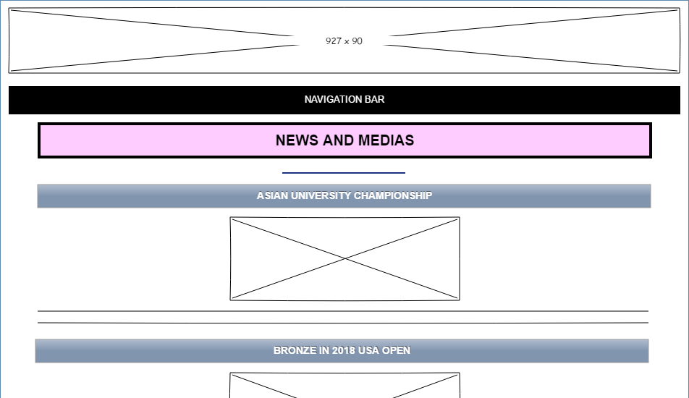

Figure 13: News and Media page

* Contact Us Page

The Contact Us page (Figure 14) is designed with a table which is spilt into three columns. The first column is an embedded google mapping that is taken from the google map (Google Map, 2018), it has shown the location of APU new campus which allows the users to zoom in and out easily. Then, the second column is the address with a location icon (OnlineWebFonts.COM, 2016), contact number, fax number and email address that are allowed the visitors to contact the APU badminton club easily. Meanwhile, the last column is about APU’s operating hours with a time icon (Marek Polakovic, 2018) that can notify the visitors before visiting to APU. The form is used for notifying the non-members and members where to find the badminton club. Hence, students would not confuse when looking for the club.

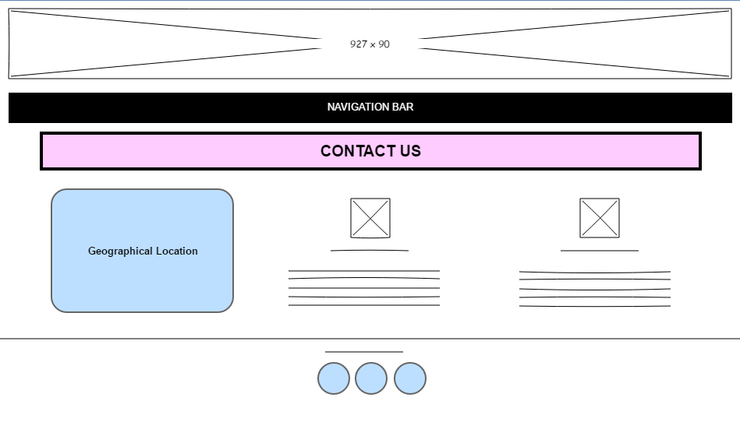

Figure 14: Contact Us page

* Our Sponsors Page

The sponsors page (Figure 15) shows a list of sponsorships that is cooperating with APU badminton club currently. Each of sponsor images will link to the related web page. The sponsor includes Yonex (Yonex, 2018), Victor (Victor, 2018), Li-Ning (Li-Ning, 2018), HSBC (HSBC, 2018), 100 plus (100 PLUS, 2018), Phiten (Phiten Malaysia, 2018), Celebrity Fitness (Celebrity Fitness Malaysia, 2018), Astro (Astro Malaysia, 2018), and Sony (SONY, 2018). It allows the students to access the web page to view more details. This form is used for showing what are the sponsors that APU badminton club with. It is also used for attracting more business or company to sponsor to the chosen club. Therefore, it may increase the funds of the club.

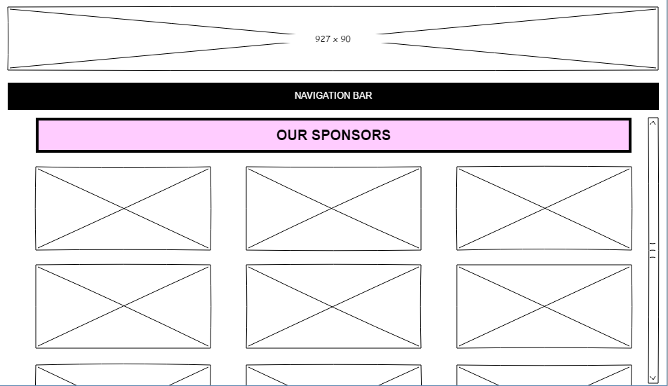

Figure 15: Our Sponsors page

**Forms** – Register, Feedback, Enquiry

By clicking the form, it will create a new tab at the same browser. These three forms are used for collecting the information or enquiries from APU students.

* Registration Form

The registration form (Figure 16) is designed for every APU students, it requires the writer to fill the details of the person, which include name, TP number, home address, contact number, course, email, and intake code that are used the textbox to get information. The gender is using the radio button to collect the gender of the writer. The date of birth input type is date, that can be selected by the writer. The types of players are using checkbox to get writer’s information. The last will be two buttons that are submit button and reset button. This form is created for non-members, it is used for sending the latest update to the recipient by emailing. So that non-members will be received the email after submitting the registration form.

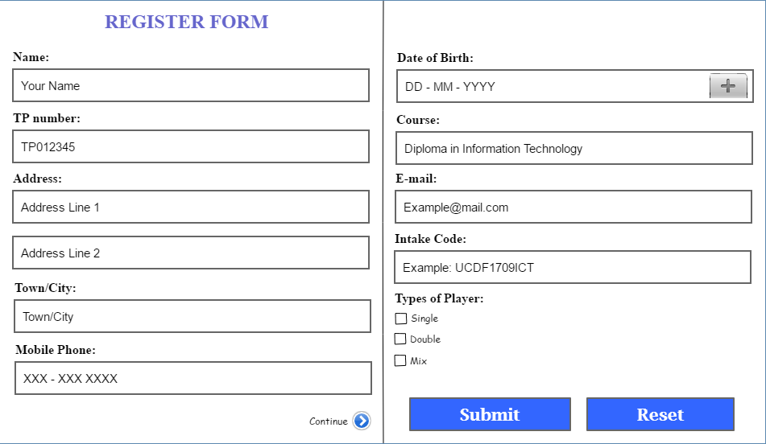

Figure 16: Registration Form page

* Feedback Form

The feedback form (Figure 17) is provided for APU badminton club members, that is used for upgrading APU badminton club’s services, system etc. Members can submit the feedback form by filling into three textboxes and one text area. To improve the badminton club, the form is used to collect the feedback from everyone, so that the badminton club can improve day by day by taking every APU student’s opinion into consideration.

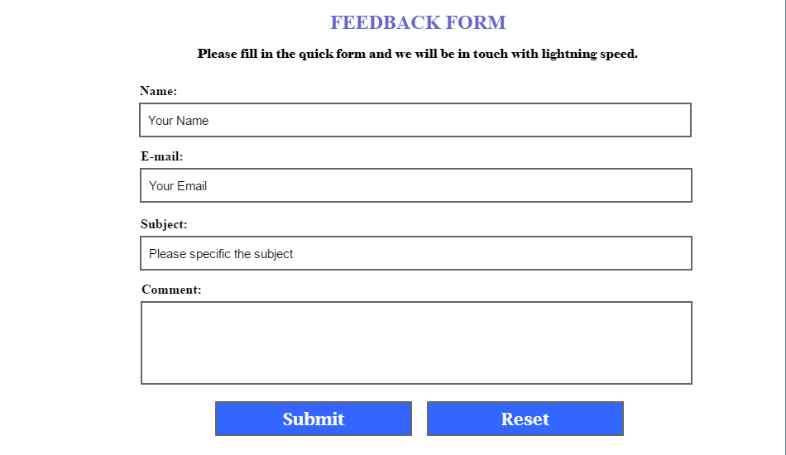

Figure 17: Feedback Form page

* Enquiry Form

The enquiry form (Figure 18) is provided for APU students, that is used for enquiring more detailed information. Students can request more information by filling into three textboxes and one text area. The reason to create this form, is allowing everyone in APU may have the question from the badminton club. This form is accepted from everyone’s question.

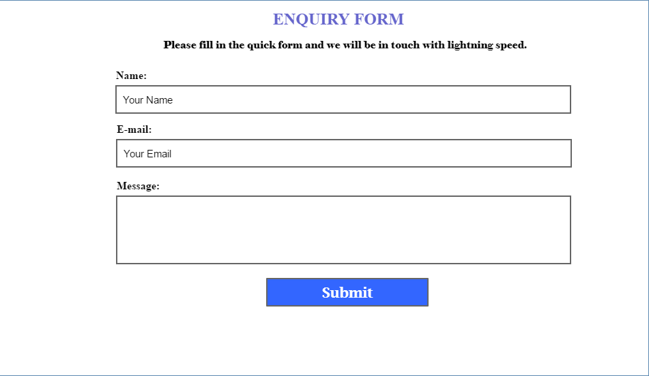

Figure 18: Enquiry Forms page

**MODELLING**

The modelling will be in PDF file, please refer to next page.

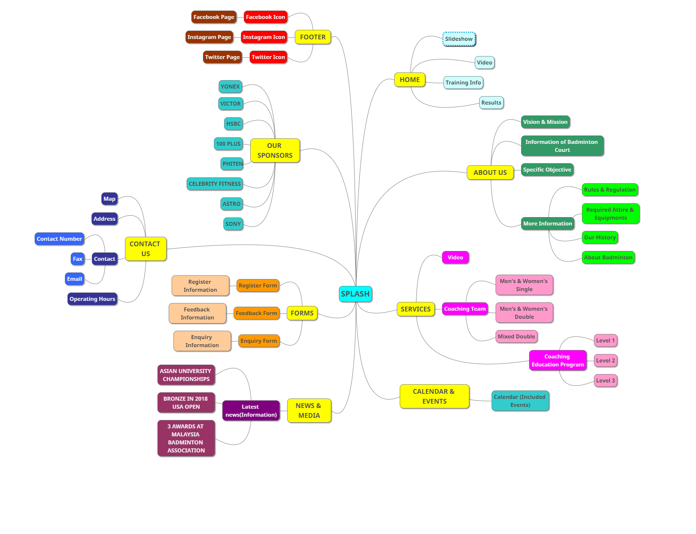**Website Architectures**

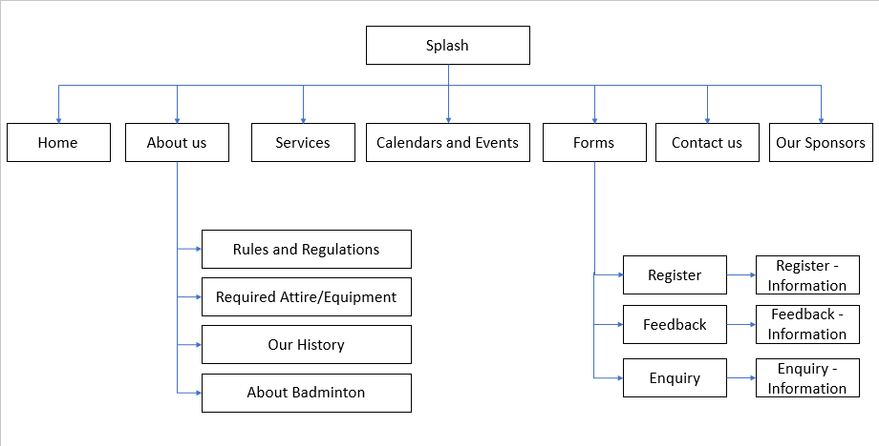**Functional Flow Chart**

In this functional flow charts, this is used to explain in briefly about the connections of each web page. From the splash page, there is a list of navigation that is connected to the related webpages which include home, about us, services, calendars and events, forms, contact us, and our sponsors. Besides that, the about us pages consist of rules and regulations, required attire or equipment, our history, and about badminton. These four webpages that can be found under about us web page. In addition, the forms consist of register, feedback, and enquiry which are for non-members and members. By submitting the any of three forms, it will link to the page that saying the form is submitted successfully. Such as register form will be going to register information, feedback form will be going to feedback information, and enquiry form will be going to enquiry information.

# Evaluation

On this assignment, there is a wide spectre of challenges while implementing to this working website. To develop a better feature and bring more conveniences to the users when using this working website, there are some evaluations to improve the functionality of this working website.

First and foremost, news and media are very rare to find on the internet. The sources are restricted to the range of the chosen topic. The topic is only stated on the badminton news and updates that related to Asia Pacific University. To overcome this major issue, the developers can try to get some news sources from the APU Beyond Media Facebook Page or search the news about the badminton. This method will help the users to get up-to-date the latest information about the APU badminton club.

Moreover, the developers are required to use certain development software to design the user interface such as Microsoft Web Expression, Microsoft Visual Studio and Adobe Dreamweaver. These common platforms only provide general features for web designers to develop a webpage. However, some development platforms offer libraries of coding and extend capabilities to make the webpage looks perfect. For instance, Atom, AppleScript Editor, PyCharm, Python and many more. Hence, unique elements that implement on a simple webpage will boost its performance and overall layout.

The last difficulty on this webpage development is the coding part. This part has consumed a lot of time for the web developers to learn and implement the computer languages into a webpage such as JavaScript, Cascading Style Sheets (CSS), and HTML. Meanwhile, there are two learning websites which are W3Schools (W3Schools.com, 2018) and Mozilla Development Network (Mozilla Development Network, 2018) that provide straight forward steps for the beginners to follow. These two learning websites have helped many of developers to finish the webpage design.

One of the challenges is time management. To complete a website within the time flame, the time management is a key challenge for a group to develop a completely new website, because the students are lack of skill in web designing fields. It may need the students to attend the class and/or reference from other websites. It requires a deep coding to develop a well-design website. Hence, it causes students may not understand the coding or give up designing a well-design website. To curb the issues, group leader must distribute equally the task and group members must fulfil the task that is given by the leader, plus the group leader set a deadline, so that the project will be finished at predicted time.

Another challenge will be the requirements of assignment. Students are supposed to fulfil the assignment requirements that was given by the lecturer. To meet the requirements, it also is another challenge for students to develop at least 10 websites within a time flame, because the students must search more information from the related website and use their own ideas to implement it into new website. Therefore, the group leader distributed the task for every group member, so that can finish the requirement on time.

The last challenge on this assignment is to meet every group member’s needs. To design a website, it could be several different ideas from group members, so it causes the conflictions among the group members. To implement group members’ own ideas, members must compromise and convince all group members about his or her own ideas. Therefore, it comes out a decision through voting among the group members. Every group member must follow the simple majority, so that the group project can be done on time.

# Future Enhancements

The future enhancements that can be implemented into this website is to manage a feature about Multilanguage options into this website, develop the website into a handheld application, develop a live stream into this working website and develop a scanner feature for QR code in this working website as well as the forms of register, enquiry and feedback.

One of the future enhancements is to provide is manage a multilingual version into this working website. This feature is one of the attractions that allows users from worldwide to visit this website and more understand about the contents according to their language.

However, the other enhancement is to develop the website into a handheld application such as iPhone application and Android application. This allows user to search this website at anytime and anywhere easily and keep their information up-to-date. It is extremely convenient for the users.

Furthermore, the other enhancement for this website is to develop a live stream for the badminton competitions or news into this website. This enhancement allows user to watch the live competitions and news through the website easily and do not need to search from the search engine and/or browser.

Meanwhile, the other enhancement is to develop a QR code for this website and/or the register form, feedback form and enquiry form. This future strongly brings convenient to users as the web site link that implements into a QR code so that user does not need to memorize the link, users can just scan the QR code directly and visits the website and same to the forms link.

In a nutshell, by having the future enhancement for each webpage design is a benefit to the creators and/or editors as it helps the creators and/or editors to improve themselves when develop a website into a high-end version and provide more and up-to-date information to attract more visitors to stop by the website.

# Conclusions

In conclusion, Badminton Club as the chosen student’s sport club in Asia Pacific University (APU). It uses Microsoft Web Expression and the combination of HTML, Cascading Style Sheets (CSS) and JavaScript file to design and develop a fully working website. During the progress of the assignment, it explores many creative design skills, examples from the Internet and gain knowledge about the coding part and try to apply into our website. At the same, some weaknesses or challenges that we faced during the development progress, it has been solved by referring to the learning websites. Therefore, it enhances us to develop a user friendly and attractive and convenient for users to use our website to have the information easily. However, we found that to attract more visitors, we should display more multimedia such as videos, icons and photos to deliver the message to the users or visitors easily.

# Reference Lists

100 PLUS, 2018. *Sports Development - 100PLUS.* [Online]   
Available at: https://100plus.com.sg/sports-development/  
[Accessed 02 September 2018].

Alpoega, 2017. *11street.my.* [Online]   
Available at: https://www.11street.my/productdetail/victor-male-badminton-running-jogging-sportswear-35286162  
[Accessed 28 September 2018].

APU Badminton Club, 2018. *APU Badminton Club - Home.* [Online]   
Available at: https://web.facebook.com/apubadmintonclub/?_rdc=1&_rdr  
[Accessed 18 September 2018].

APU Badminton, 2018. *Sports and Recreation.* [Online]   
Available at: https://www.studentaffairs.apu.edu.my/large-grid  
[Accessed 19 August 2018].

APU Beyond Media, 2017. *APU-Sunway Badminton Tournament 2017 - Asia Pacific University (APU) Malaysia.* [Online]   
Available at: https://www.youtube.com/watch?v=m5fyrH2q9LM  
[Accessed 28 August 2018].

Astro Malaysia, 2018. *Astro Malaysia Holdings Berhad.* [Online]   
Available at: https://corporate.astro.com.my/  
[Accessed 02 September 2018].

Badminton Association of Malaysia - Coaching Team, 2018. *Badminton Association of Malaysia - Coaching Team.* [Online]   
Available at: http://www.bam.org.my/national-team/coaching-team  
[Accessed 01 September 2018].

Bryson, M., 2017. *A senior badminton final in name only - The Record.* [Online]   
Available at: https://www.therecord.com/sports-story/7240837-a-senior-badminton-final-in-name-only/  
[Accessed 09 September 2018].

Celebrity Fitness Malaysia, 2018. *Celebrity Fitness Malaysia - Gym club and Fitness Center.* [Online]   
Available at: https://www.celebrityfitness.com/my/  
[Accessed 02 September 2018].

D'Addese, A., 2017. *Badminton searches for first title at OUAs - The Official Site for Ryerson University Athletics.* [Online]   
Available at: http://www.ryersonrams.ca/ViewArticle.dbml?DB_OEM_ID=22300&ATCLID=211479413  
[Accessed 09 September 2018].

DHgate.com, 2018. *Badminton jersey.* [Online]   
Available at: https://m.uk.dhgate.com/product/badminton-jersey-badminton-tennis-jersey/379860454.html#s1-23-1;uk|3670104432  
[Accessed 28 September 2018].

Dumielauxepices.net, 2018. *Animation Clipart Badminton.* [Online]   
Available at: https://dumielauxepices.net/sites/default/files/animation-clipart-badminton-841206-950408.gif  
[Accessed 28 September 2018].

E-badminton Club, 2018. *E-badmintonclub Training Centre.* [Online]   
Available at: https://www.e-badmintonclub.com/updates  
[Accessed 09 September 2018].

EZtrust, W., 2015. *DUNLOP BADMINTON RACKET SET.* [Online]   
Available at: http://themdsports.com/en/products/show.php?num=552&page=25&k&bvstate=pg:2/ct:r  
[Accessed 28 September 2018].

Flipkart.com, 2018. *Badminton Shoes Sports Shoes.* [Online]   
Available at: https://www.flipkart.com/mens-footwear/sports-shoes/badminton-shoes~type/pr?sid=osp%2Ccil%2C1cu  
[Accessed 28 September 2018].

Flipkart.com, 2018. *Jaspo STYLE Badminton Kit.* [Online]   
Available at: https://www.flipkart.com/jaspo-style-badminton-kit/p/itmf3wa5g6gvdxzt  
[Accessed 28 September 2018].

Google Calendar, 2018. *Google Calendar.* [Online]   
Available at: https://calendar.google.com/calendar/r/month/2018/8/1?tab=lc  
[Accessed 03 September 2018].

Google Map, 2018. *Google Map.* [Online]   
Available at: https://www.google.com/maps/place/Asia+Pacific+University+of+Technology+%26+Innovation+(APU)/@3.055072,101.698563,17z/data=!4m5!3m4!1s0x31cc4abb795025d9:0x1c37182a714ba968!8m2!3d3.055072!4d101.7007517  
[Accessed 22 August 2018].

Health, S., 2018. *Paytm Mall.* [Online]   
Available at: https://paytmmall.com/ashirwad-4-pic-combo-knee-ankle-elbow-and-palm-supports-SPOASHIRWAD-4-PASHI6275267D46394-pdp   
[Accessed 28 September 2018].

HSBC, 2018. *HSBC nets badminton sponsorship.* [Online]   
Available at: https://www.hsbc.com/news-and-insight/insight-archive/2018/hsbc-nets-badminton-sponsorship  
[Accessed 02 September 2018].

Joybuy, 2018. *Item.jd.com.* [Online]   
Available at: http://item.jd.com/16425707709.html  
[Accessed 28 September 2018].

Khelmart.org, 2018. *It's all about Sports..* [Online]   
Available at: http://khelmart.org/tag/best-badminton-shoes/  
[Accessed 28 September 2018].

Li-Ning, 2018. *USA & Canada Athlete Sponsorships.* [Online]   
Available at: https://www.li-ning-sports.com/athlete-sponsorships  
[Accessed 02 September 2018].

Marek Polakovic, S., 2018. *The Noun Project.* [Online]   
Available at: https://thenounproject.com/term/time/97316/  
[Accessed 22 August 2018].

Mozilla Development Network, 2018. *MDN Web Docs.* [Online]   
Available at: https://developer.mozilla.org/my/  
[Accessed 12 September 2018].

OMG Fitness, 2017. *Badminton Players Exercise | OMG Fitness - Your Personal Trainer.* [Online]   
Available at: http://www.personaltrainersg.com/2017/08/22/bodyweight-exercises-badminton-players/  
[Accessed 28 September 2018].

OnlineWebFonts.COM, 2016. *Nearby (address) Svg.* [Online]   
Available at: https://www.onlinewebfonts.com/icon/339206  
[Accessed 22 August 2018].

Patenik, 2018. *11en1.nl.* [Online]   
Available at: https://11en1.nl/wp-content/uploads/2017/04/patenik.gif  
[Accessed 28 September 2018].

Phiten Malaysia, 2018. *Phiten Malaysia - Everything we do, we do for health.* [Online]   
Available at: http://www.phitenmy.com/  
[Accessed 02 September 2018].

Sikana English, 2018. *How to Hit a High Forehand Serve | Badminton.* [Online]   
Available at: https://www.youtube.com/watch?v=fr0HFft4PQ0  
[Accessed 03 September 2018].

SONY, 2018. *Sony Malaysia - Latest Technology and News.* [Online]   
Available at: https://www.sony.com.my/  
[Accessed 02 September 2018].

The Wild Honey Pie, 2018. *The Wild Honey Pie.* [Online]   
Available at: https://www.thewildhoneypie.com/  
[Accessed 21 August 2018].

Victor, 2018. *Victor Sponsorship.* [Online]   
Available at: https://www.victor-sport.co.uk/index.php?page=sponsorship  
[Accessed 02 September 2018].

W3Schools.com, 2018. *W3Schools Online Web Tutorials.* [Online]   
Available at: https://www.w3schools.com/  
[Accessed 12 September 2018].

Yonex, 2018. *Yonex.* [Online]   
Available at: http://www.yonex.com/company/yonex-distributors/oceania/  
[Accessed 02 September 2018].

**List of Figures**

[Figure 1: Layout for all webpages 7](https://cloudmails-my.sharepoint.com/personal/tp047472_mail_apu_edu_my/Documents/OneDrive%20-%20Asia%20Pacific%20University/APU%20Diploma/Semester%203/Internet%20Application/Assignment/Internet%20Application%20Documentation.docx#_Toc526102797)

[Figure 2: Layout for forms 7](https://cloudmails-my.sharepoint.com/personal/tp047472_mail_apu_edu_my/Documents/OneDrive%20-%20Asia%20Pacific%20University/APU%20Diploma/Semester%203/Internet%20Application/Assignment/Internet%20Application%20Documentation.docx#_Toc526102798)

[Figure 3: Appreciated forms 8](https://cloudmails-my.sharepoint.com/personal/tp047472_mail_apu_edu_my/Documents/OneDrive%20-%20Asia%20Pacific%20University/APU%20Diploma/Semester%203/Internet%20Application/Assignment/Internet%20Application%20Documentation.docx#_Toc526102799)

[Figure 4: Splash page 9](https://cloudmails-my.sharepoint.com/personal/tp047472_mail_apu_edu_my/Documents/OneDrive%20-%20Asia%20Pacific%20University/APU%20Diploma/Semester%203/Internet%20Application/Assignment/Internet%20Application%20Documentation.docx#_Toc526102800)

[Figure 5: Home page 10](https://cloudmails-my.sharepoint.com/personal/tp047472_mail_apu_edu_my/Documents/OneDrive%20-%20Asia%20Pacific%20University/APU%20Diploma/Semester%203/Internet%20Application/Assignment/Internet%20Application%20Documentation.docx#_Toc526102801)

[Figure 6: About Us page 11](https://cloudmails-my.sharepoint.com/personal/tp047472_mail_apu_edu_my/Documents/OneDrive%20-%20Asia%20Pacific%20University/APU%20Diploma/Semester%203/Internet%20Application/Assignment/Internet%20Application%20Documentation.docx#_Toc526102802)

[Figure 7: Rules and Regulations 12](https://cloudmails-my.sharepoint.com/personal/tp047472_mail_apu_edu_my/Documents/OneDrive%20-%20Asia%20Pacific%20University/APU%20Diploma/Semester%203/Internet%20Application/Assignment/Internet%20Application%20Documentation.docx#_Toc526102803)

[Figure 8: Attire and Equipment page 13](https://cloudmails-my.sharepoint.com/personal/tp047472_mail_apu_edu_my/Documents/OneDrive%20-%20Asia%20Pacific%20University/APU%20Diploma/Semester%203/Internet%20Application/Assignment/Internet%20Application%20Documentation.docx#_Toc526102804)

[Figure 9: Our history page 14](https://cloudmails-my.sharepoint.com/personal/tp047472_mail_apu_edu_my/Documents/OneDrive%20-%20Asia%20Pacific%20University/APU%20Diploma/Semester%203/Internet%20Application/Assignment/Internet%20Application%20Documentation.docx#_Toc526102805)

[Figure 10: About badminton page 15](https://cloudmails-my.sharepoint.com/personal/tp047472_mail_apu_edu_my/Documents/OneDrive%20-%20Asia%20Pacific%20University/APU%20Diploma/Semester%203/Internet%20Application/Assignment/Internet%20Application%20Documentation.docx#_Toc526102806)

[Figure 11: Services page 16](https://cloudmails-my.sharepoint.com/personal/tp047472_mail_apu_edu_my/Documents/OneDrive%20-%20Asia%20Pacific%20University/APU%20Diploma/Semester%203/Internet%20Application/Assignment/Internet%20Application%20Documentation.docx#_Toc526102807)

[Figure 12: Calendars and Events page 17](https://cloudmails-my.sharepoint.com/personal/tp047472_mail_apu_edu_my/Documents/OneDrive%20-%20Asia%20Pacific%20University/APU%20Diploma/Semester%203/Internet%20Application/Assignment/Internet%20Application%20Documentation.docx#_Toc526102808)

[Figure 13: News and Media page 18](https://cloudmails-my.sharepoint.com/personal/tp047472_mail_apu_edu_my/Documents/OneDrive%20-%20Asia%20Pacific%20University/APU%20Diploma/Semester%203/Internet%20Application/Assignment/Internet%20Application%20Documentation.docx#_Toc526102809)

[Figure 14: Contact Us page 19](https://cloudmails-my.sharepoint.com/personal/tp047472_mail_apu_edu_my/Documents/OneDrive%20-%20Asia%20Pacific%20University/APU%20Diploma/Semester%203/Internet%20Application/Assignment/Internet%20Application%20Documentation.docx#_Toc526102810)

[Figure 15: Our Sponsors page 20](https://cloudmails-my.sharepoint.com/personal/tp047472_mail_apu_edu_my/Documents/OneDrive%20-%20Asia%20Pacific%20University/APU%20Diploma/Semester%203/Internet%20Application/Assignment/Internet%20Application%20Documentation.docx#_Toc526102811)

[Figure 16: Registration Form page 21](https://cloudmails-my.sharepoint.com/personal/tp047472_mail_apu_edu_my/Documents/OneDrive%20-%20Asia%20Pacific%20University/APU%20Diploma/Semester%203/Internet%20Application/Assignment/Internet%20Application%20Documentation.docx#_Toc526102812)

[Figure 17: Feedback Form page 22](https://cloudmails-my.sharepoint.com/personal/tp047472_mail_apu_edu_my/Documents/OneDrive%20-%20Asia%20Pacific%20University/APU%20Diploma/Semester%203/Internet%20Application/Assignment/Internet%20Application%20Documentation.docx#_Toc526102813)

[Figure 18: Enquiry Forms page 23](https://cloudmails-my.sharepoint.com/personal/tp047472_mail_apu_edu_my/Documents/OneDrive%20-%20Asia%20Pacific%20University/APU%20Diploma/Semester%203/Internet%20Application/Assignment/Internet%20Application%20Documentation.docx#_Toc526102814)

# Attachments

1st Fortnightly Report

|  |  |  |  |
| --- | --- | --- | --- |
| VENUE | START TIME | END TIME | DATE |
| B-08-08 | 0830 | 1030 | 06/08/2018 |

|  |  |  |  |
| --- | --- | --- | --- |
| **MEMBERS NAME** | **INTAKE NUMBER** | **ATTENDANCE** | **SIGNATURE** |
| Hen Kian Jun | TP047472 | Present |  |
| Lee Wai Yen | TP044610 | Present |  |
| Teh Yi Jia | TP048096 | Present |  |

**What we have done?**

* Assign a group leader
* Discuss what is the categories that we want to choose
* Designing the layout storyboard and deciding what web pages should be included according to the assignment question
* Tasks distribution for all members

**What we are doing?**

Started doing the HTML code and CSS

**What we will do?**

We will start to design the layout for every web page maintains the same layout. The next group meeting will be held on 27 August 2018 at B-08-08, APU New campus.



2nd Fortnightly Report

|  |  |  |  |
| --- | --- | --- | --- |
| VENUE | START TIME | END TIME | DATE |
| B-08-08 | 0830 | 1030 | 27/08/2018 |

|  |  |  |  |
| --- | --- | --- | --- |
| **MEMBERS NAME** | **INTAKE NUMBER** | **ATTENDANCE** | **SIGNATURE** |
| Hen Kian Jun | TP047472 | Present |  |
| Lee Wai Yen | TP044610 | Present |  |
| Teh Yi Jia | TP048096 | Present |  |

**What we have done?**

* Done the design layout for every web page
* Finished the home page

**What we are doing?**

Keep designing for web pages

**What we will do?**

We will continue to design for all web pages. the next group meeting will be held on 28 August 2018 at Library, APU new campus.



3rd Fortnightly Report

|  |  |  |  |
| --- | --- | --- | --- |
| VENUE | START TIME | END TIME | DATE |
| Library, APU New Campus | 0830 | 1030 | 28/08/2018 |

|  |  |  |  |
| --- | --- | --- | --- |
| **MEMBERS NAME** | **INTAKE NUMBER** | **ATTENDANCE** | **SIGNATURE** |
| Hen Kian Jun | TP047472 | Present |  |
| Lee Wai Yen | TP044610 | Present |  |
| Teh Yi Jia | TP048096 | Present |  |

**What we have done?**

* Group leader was checking the progression from each member, and combining the HTML code and CSS
* Finished the Contact Us and Our Sponsors pages

**What we are doing?**

Keep coding HTML for each web page, group leader started to do storyboarding in Pencils

**What we will do?**

We will continue to design for the remaining web pages. The next group meeting will be held on 12 September 2018 at Library, APU new campus.



4th Fortnightly Report

|  |  |  |  |
| --- | --- | --- | --- |
| VENUE | START TIME | END TIME | DATE |
| Library, APU New Campus | 0830 | 1030 | 12/09/2018 |

|  |  |  |  |
| --- | --- | --- | --- |
| **MEMBERS NAME** | **INTAKE NUMBER** | **ATTENDANCE** | **SIGNATURE** |
| Hen Kian Jun | TP047472 | Present |  |
| Lee Wai Yen | TP044610 | Present |  |
| Teh Yi Jia | TP048096 | Present |  |

**What we have done?**

* Group leader has done the storyboarding
* Each member started to code the webpage according to the storyboard.

**What we are doing?**

Continue doing the HTML code, CSS and JavaScript for each webpage.

**What we will do?**

We will finish the coding part for each webpage and insert more images to the webpage and start doing the documentation. The next group meeting will be held on 18 September 2018 at B-08-08, APU new campus.



5th Fortnightly Report

|  |  |  |  |
| --- | --- | --- | --- |
| VENUE | START TIME | END TIME | DATE |
| B-08-08 | 0830 | 1030 | 18/09/2018 |

|  |  |  |  |
| --- | --- | --- | --- |
| **MEMBERS NAME** | **INTAKE NUMBER** | **ATTENDANCE** | **SIGNATURE** |
| Hen Kian Jun | TP047472 | Present |  |
| Lee Wai Yen | TP044610 | Present |  |
| Teh Yi Jia | TP048096 | Present |  |

**What we have done?**

* Introduction, Abstract, and Storyboard have been done in documentation
* Websites have been done completely.

**What we are doing?**

* Continue to do the documentation
* Group leader assigned tasks for other members, Teh Yi Jia has been assigned to do Evaluation, Lee Wai Yen has been assigned to do Future Enhancement.

**What we will do?**

Group leader will check the progression from two group members, and the next meeting will be held on 24 September 2018 at B-08-08, APU New campus.



6th Fortnightly Report

|  |  |  |  |
| --- | --- | --- | --- |
| VENUE | START TIME | END TIME | DATE |
| B-08-08 | 0830 | 1030 | 24/09/2018 |

|  |  |  |  |
| --- | --- | --- | --- |
| **MEMBERS NAME** | **INTAKE NUMBER** | **ATTENDANCE** | **SIGNATURE** |
| Hen Kian Jun | TP047472 | Present |  |
| Lee Wai Yen | TP044610 | Present |  |
| Teh Yi Jia | TP048096 | Present |  |

**What we have done?**

* Group members have done their own parts

**What we are doing?**

Finalised the documentation, and asked for advices from the lecturer

**What we will do?**

Check the documentation whether to add more. The next group meeting will be held on 26 September 2018 at library, APU New Campus.



7th Fortnightly Report

|  |  |  |  |
| --- | --- | --- | --- |
| VENUE | START TIME | END TIME | DATE |
| Library | 1600 | 1800 | 26/09/2018 |

|  |  |  |  |
| --- | --- | --- | --- |
| **MEMBERS NAME** | **INTAKE NUMBER** | **ATTENDANCE** | **SIGNATURE** |
| Hen Kian Jun | TP047472 | Present |  |
| Lee Wai Yen | TP044610 | Present |  |
| Teh Yi Jia | TP048096 | Present |  |

**What we have done?**

* To add more evaluation
* To add more web pages

**What we are doing?**

Designing webpages for Rules and Regulations, Required Attire or Equipment, About badminton, and our history of APU badminton club

**What we will do?**

To design PowerPoint slides and will be checked by group leader. The next group meeting will be held on 29 September 2018 at McDonald’s, Sri Petaling.



8th Fortnightly Report

|  |  |  |  |
| --- | --- | --- | --- |
| VENUE | START TIME | END TIME | DATE |
| McDonald’s, Sri Petaling | 1300 | 1600 | 29/09/2018 |

|  |  |  |  |
| --- | --- | --- | --- |
| **MEMBERS NAME** | **INTAKE NUMBER** | **ATTENDANCE** | **SIGNATURE** |
| Hen Kian Jun | TP047472 | Present |  |
| Lee Wai Yen | TP044610 | Present |  |
| Teh Yi Jia | TP048096 | Present |  |

**What we have done?**

Everything has been done.

**What we are doing?**

Checked and edited some in PowerPoint slides and also documentation.

**What we will do?**

Report is completed.

**Work Breakdown Structure**

|  |  |  |
| --- | --- | --- |
| **No.** | **Name** | **Tasks** |
| 1 | Hen Kian Jun | 1. Designed the default layout for each web page 2. Designed for Home page and About us page 3. Designed for Splash page, About badminton page 4. Combined the group members’ HTML code and CSS file   **Documentation**   1. Designed for storyboarding 2. Introductions 3. Explanation on storyboarding 4. Inserting citation |
| 2 | Lee Wai Yen | 1. Designed for Contact Us page and Our Sponsors page 2. Designed for Calendars and Events page and the three forms with JavaScript 3. Designed for Rules and Regulations page, Required Attire/Equipment page, Our history page 4. Find the materials and information from online   **Documentation**   1. Acknowledgement, Conclusion and Future Enhancements 2. Inserting citation |
| 3 | Teh Yi Jia | 1. Designed for Services page and News and Medias page 2. Find the materials and information from online   **Documentation**   1. Evaluation |

______________ ______________ ______________

Hen Kian Jun Lee Wai Yen Teh Yi Jia